# Authors: Rokas Lukosevicius, Piotr Kawalec, Robert Gabriel and Aron Natnael.

# Use-Case Glossary

## Introduction

This document is used to define terminology specific to the problem domain, explaining terms, which may be unfamiliar to the reader of the use-case descriptions or other project documents. Often, this document can be used as an informal *data dictionary*, capturing data definitions so that use-case descriptions and other project documents can focus on what the system must do with the information.

|  |  |  |
| --- | --- | --- |
| **Use-Case Name** | **Use-Case Description** | **Participating**  **Actors and Roles** |
| Login | The login process. | Employee, Staff Department and Manager |
| Update employee secure data | Updating pay rates,job title and supervisor for employees. | HR |
| Update Employee profile | Updating the employee profile information. | Employee, HR |
| View United Way participation | Viewing united way participant for all employee. | Manager, Employee |
| Enter employee profile | Entering a new employee. | Staff Department |
| Perform employee details lookup | Viewing list of employees in any department. | Manager |
| Perform employee group lookup | Viewing employees based on various selection condition like job code, building, department, salary, city, employee status and so on. | Manager |
| View employee profile | A complete profile for a single employee. | Employee, Manager, Staff Department and HR |

# Use-Case Model Diagram

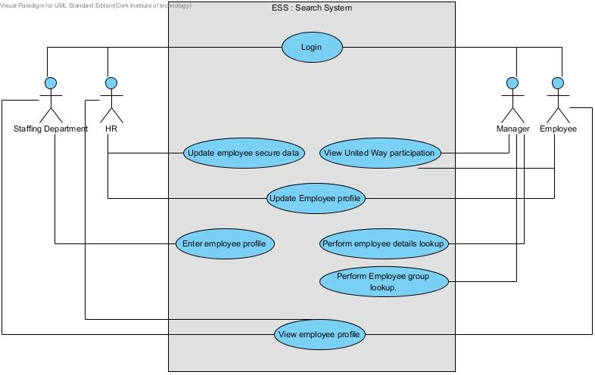

# Use Case Narrative: *Search Employee Directory*

**The Ultimate Login System ever.**

**Author (s): Kira Webster Date: 29/10/2013**

**Version: 001**

|  |  |
| --- | --- |
| **USE CASE NAME:** | Search Employee Directory |
| **USE CASE ID:** | Esss-001 |
| **PRIORITY:** | High |
| **SOURCE:** | Requirement - MSS-R1.00 |
| **PRIMARY BUSINESS ACTOR:** | Employee |
| **OTHER PARTICIPATING ACTORS:** | Manager, Department’s Staff, HR |
| **OTHER INTERESTED STAKEHOLDERS:** | System database |
| **DESCRIPTION:** | Allows users to search employee database |
| **PRE-CONDITION:** | Must be registered and be an employee . Also login. |
| **TRIGGER:** | Looking for information or the need for updating |

|  |  |  |
| --- | --- | --- |
| **TYPICAL COURSE OF EVENTS:** | **Actor Action** | **System Response** |
| **Step 1**: | User logs in | System displays search screen with additional options depending from user credentials |
| **Step2**: | User enters search criteria and presses ‘OK’ | System displays list of everyone whose criteria are met and links to the detailed view |
| **Step 3**: | Users goes to detailed view | System displays detailed information |
| **Step 4**: | User goes back to previous screens or exits | System displays previous screen or login screen when user exits |

|  |  |  |
| --- | --- | --- |
| **ALTERNATE COURSES:** | **Actor Action** | **System Response** |
| At step2: user is an employee | User decides to update non-secure data | System displays form with data to be changed. |
|  | User types in new data and submits | System confirms change and goes back to Step2 |
| At Step2: user is a department’s staff | User decides to update secure or non-secure data | System displays form with data to be changed. |
|  | User types in new data and submits | System confirms change and goes back to Step2 |
| At Step2: user is a department’s staff | User decides to enter new employee details | System displays form with data to be filled in. |
|  | User types in new data and submits | System confirms change and goes back to Step2 |
| At Step2: user is a manager | User enters search criteria or uses SQL interface provided. User selects search option: detailed lookup, group lookup, employee profile or United Way Participation | System displays information according to selected option and criteria |
|  | User goes back to Step 2 or exits | System displays appropriate screen |

|  |  |
| --- | --- |
| **CONCLUSION:** | when the user cancels the search or exists the detailed information screen. |
| **POSTCONDITION:** | None |
| **BUSINESS RULES** | None |
| **IMPLEMENTATION CONSTRAINTS AND SPECIFICATIONS** | Web programming to be used so employees can have easy remote access. |
| **ASSUMPTIONS:** | None |
| **OPEN ISSUES:** | Need to be verify which information should displayed or should not be displayed |